City of Baldwin
Water Reservoir Sediment Removal
Banks and Habersham Counties, Georgia
Services Provided:

Preliminary Planning
Design and Permitting
Bid Phase Management
Construction Observation
Engineering During Construction

Project Data:

Project consists of, but is not limited to, construction of a 20’ x 24’ split faced block building, installation of two (2) existing close coupled end suction pumps; supply and installation of associated piping, valves, meters, electrical, etc.; clearing, grubbing, grading, drainage, fencing and other miscellaneous appurtenances.

Total Project Cost:
$195,200

Date of Completion:
March 2017

Contact:

City of Baldwin
The Honorable Joe Elam
Mayor
186 Highway 441
Baldwin, Georgia 30511
(706)778-6341

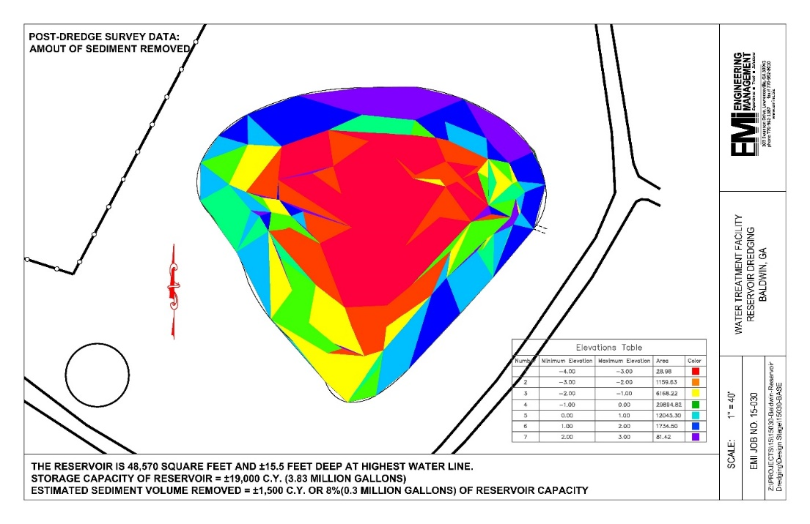
The City of Baldwin owns and operates a 4.0 million-gallon (MG) Water Treatment Facility. The facility’s raw water is supplied from a raw water intake from the Chattahoochee River. Due to the nature of the water supply from a river and the actual raw intake structure, the raw water has high sediment levels. The raw water is pumped into a 3.83 MG raw water reservoir for pre-sedimentation prior to being treated at the water treatment facility. Over the years, the raw water reservoir developed excessive sediment that caused a reduction in storage capacity.

In order to regain storage capacity in the reservoir, the City contracted with Engineering Management, Inc. to develop a plan for increased storage capacity in the water reservoir. EMI provided design, and permitting services, as well as engineering services during and post construction.

Because of site restrictions, accessibility to the reservoir for sediment removal had challenges. The City, with the guidance of EMI, was able to work through these barriers by utilizing a belt press rather than geotubes and removing a fence temporarily. The dewatered sediment was hauled to a City-owned location so that the City could utilize the sediment for fill dirt.

A 3-dimensional survey of the bottom of the pond was created for both pre- and post-dredging in order to evaluate the success of the sediment removal. The resulting increased storage capacity from the project yielded 0.3 MG additional capacity.

